YOGA THERAPY INTAKE FORM CONTINUED

Please Circle any areas of pain/concern. You will be able to discuss this with your Yoga Therapist.

(Describe pain, does anything make it better/worse?)

Front Back

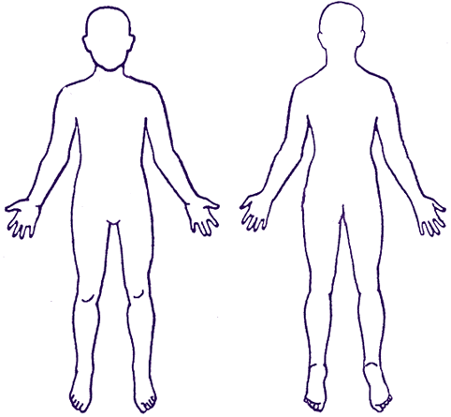

Do you eat regular meals? Y N

How much water do you drink daily?

How much caffeine do you consume in a day?

Please circle any of the following sensations you may be experiencing

Negative Self-Talk Fear Grief Anger Sadness Despair Other (please explain)